Best Programming Practices

Commenting

Before chunks of code, leave a comment stating what the purpose of the chunk is and what the expected output, if any, will be.

For example:

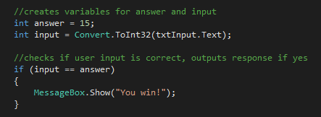

*//creates variables for answer and input*

*int answer = 15;*

*int input = Convert.ToInt32(txtInput.Text);*

*//checks if user input is correct, outputs response if yes*

*if (input == answer) {*

*MessageBox.Show(“You win!”);*

*}*

Naming

Variable names need to be clear and easily understood. Don’t be afraid to have long, but specific names - C# remembers your variables so you won’t have to type them out every time.

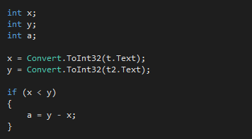

*int x;*

*int y;*

*int a;*

*x = Convert.ToInt32(t.Text);*

*y = Convert.ToInt32(t2.Text);*

*if (x < y)*

*{*

*a = y - x;*

*}*

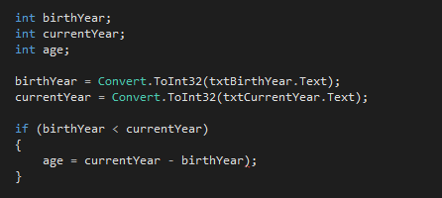

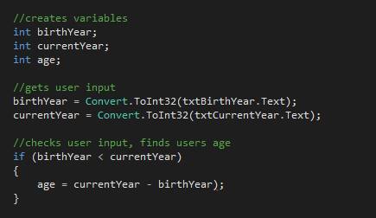

*//creates variables*

*int birthYear;*

*int currentYear;*

*int age;*

*//gets user input*

*birthYear = Convert.ToInt32(txtBirthYear.Text);*

*currentYear = Convert.ToInt32(txtCurrentYear.Text);*

*//checks user input, finds users age*

*if (birthYear < currentYear)*

*{*

*age = currentYear - birthYear);*

*}*

Pseudo-code

Pseudo-code is a blueprint for your program. It is intended for you, a human, to read, NOT for a computer to read.

For example:

create variables birthYear, currentYear, age

get user input for birthYear, currentYear

IF birthYear is smaller than currentYear

age equals currentYear minus birthYear

END IF

This is a basic level description of the above code. This type of pseudo-code is universal and clear, so you could transfer it into almost any programming language.